CSCE 606 - Vaccine Hesitancy Game: Iteration 1

**Team roles:**

* Scrum Master: Catherine Shen
* Product Owner: Benjamin Hawn
* Team Member: Liuyi Jin
* Team Member: Bhogesh Maddirala

**Github repo:** <https://github.com/bhawn/CSCE_606_Project>

**Pivotal Tracker:** <https://www.pivotaltracker.com/n/projects/2536278>

**Deployment:** Not completed for this iteration

**Customer Meeting Date:**

* (10/28/21) Exchanged messages over email with customer, Dr. Walker.
  + Send a document listing possible game ideas in order to get feedback and approval to begin work towards our finalized project idea.
  + Discussed that while the game ideas are fine, we need to be able to have the game done, tested, and deployed by the end of the semester. I.e. Try to make a simple game before trying to make anything fancy.
* (10/22/21-10/24/21) Exchanged series of emails with the web developer, Samiksha Marne, of the website where our completed project will be deployed to.
  + Discussed, if there would be any html or javascript constraints we would be under and where our finalized game would be hosted in order to account for existing html elements.

**User Stories:**

* Completed:
  + Write iteration report 0
  + Write iteration report 1
  + Finalize idea for a vaccine game
    - Discussed, refined, created multiple of, and got approval for a finalized idea of a vaccine themed game where the focus should be on the game aspect over education.
  + Discussed, tested, and finalized a choice for a JavaScript game framework.
    - As a developer,

We want to choose a JavaScript framework

So that we could build our vaccine game

* Current User Stories
  + Feature: Player Entity Movement

As a Player

I want to move my character.

So I can explore or dodge enemies in the game.

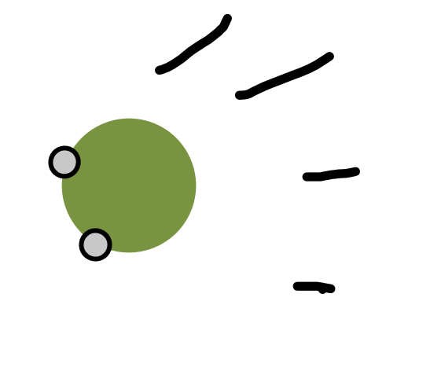

* + Feature: Create Enemy Entity

As a Player

I want to encounter enemies (viruses)

So that I can attack or run away from them.

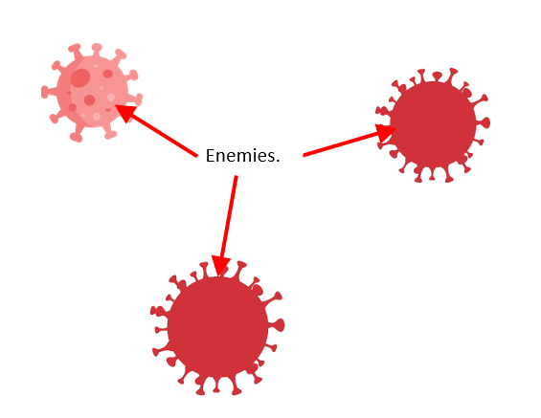

* + Feature: Enemy Entity Movement

As a Player

I want enemies to move towards me

So that there is something I need to overcome to win.

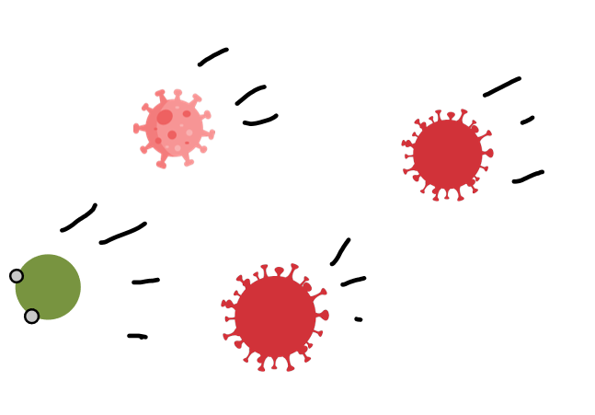

* + Feature: Entity Collision (pick up drop, damage, etc)

As a Player

I want to interact with other entities

So that I can interact with different things in the game.

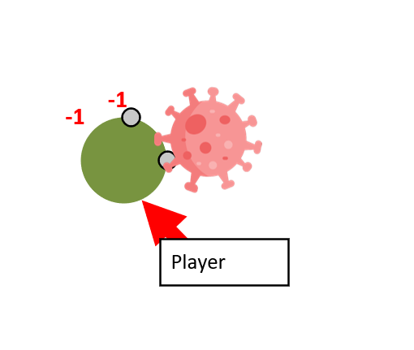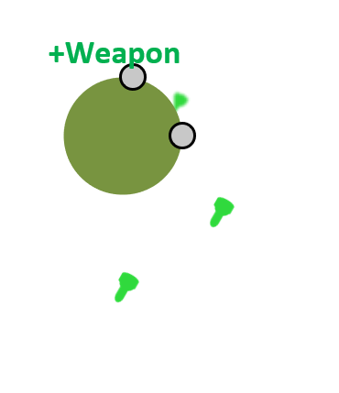

* + Feature: Create Attack Methods

As a Player

I want to shoot antibodies/tcells/etc at viruses

So that I can attack and destroy them.

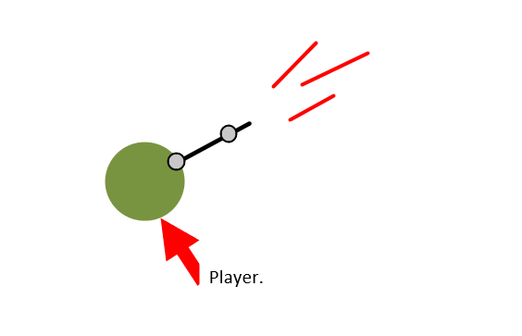

* + Feature: Create Drop entities

As a Player

I want to encounter drops (vaccines, spike proteins)

So I can improve my attacks.

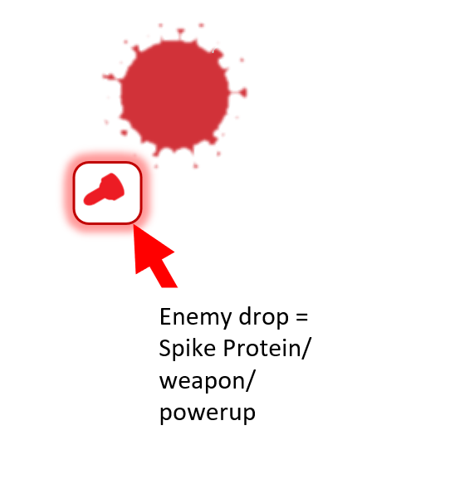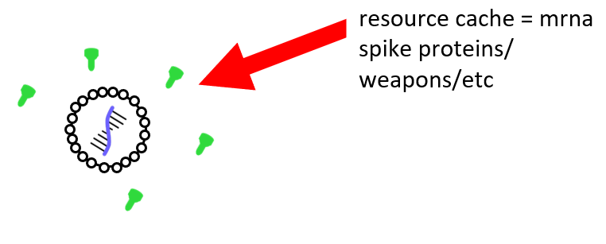

**Design Diagram:**

* Diagram of General Overview of what game will contain.
  + Some of these can be broken down into further parts and further refined, however, this can wait until those user stories are developed and worked on.

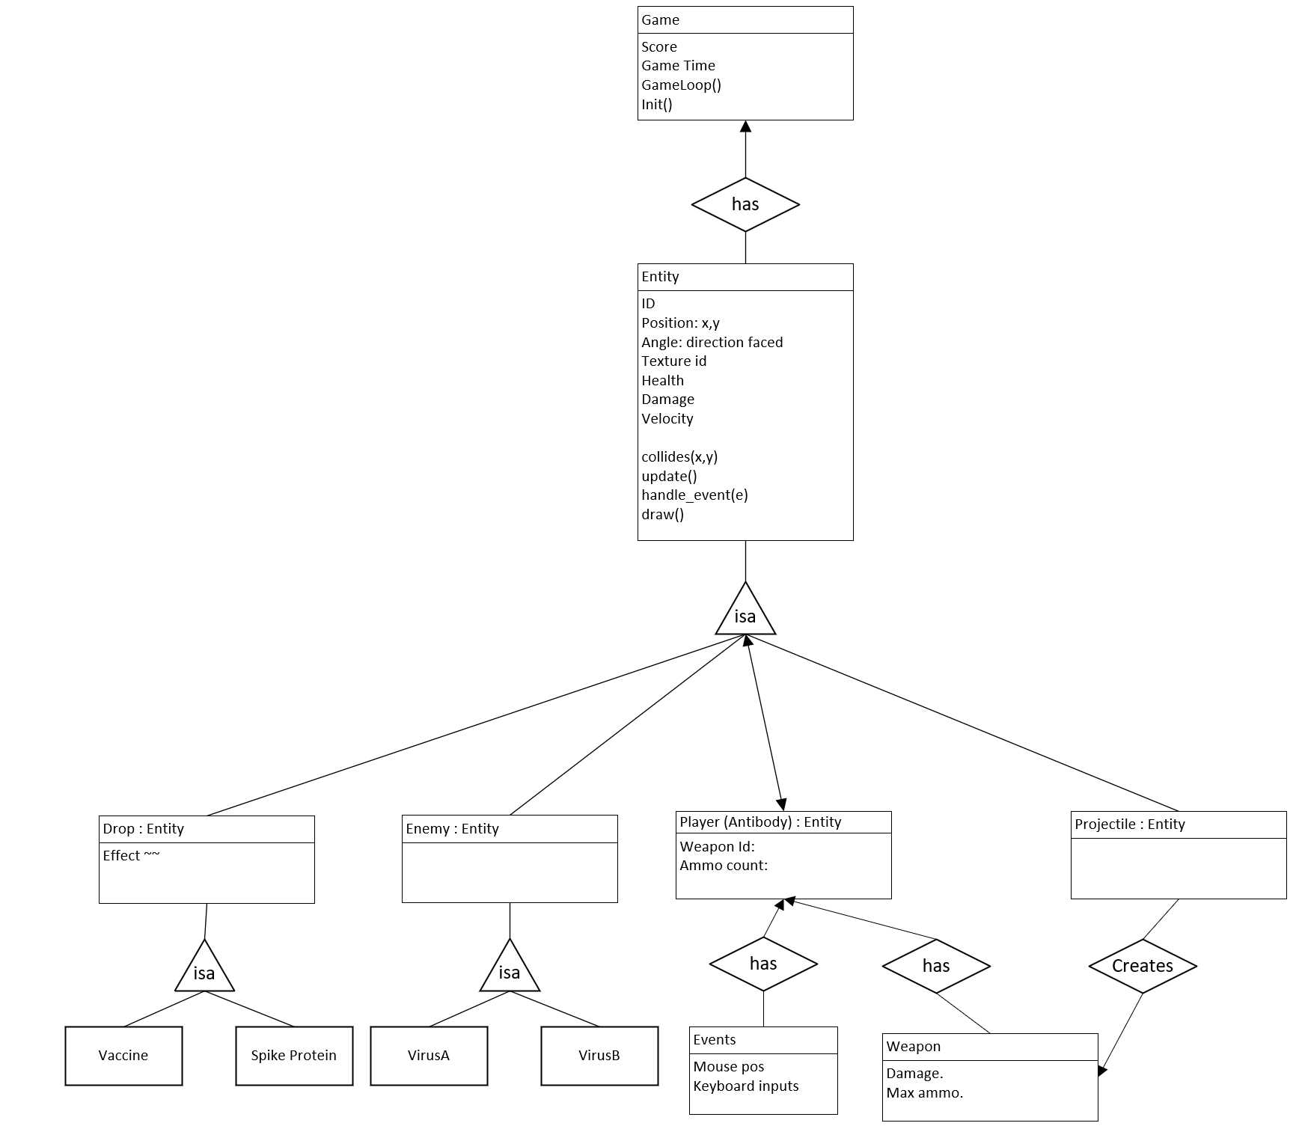

**Lo-Fi UIs:**

Updated Lo-Fi UI’s

* Created during game idea brainstorm and approval process.
  + 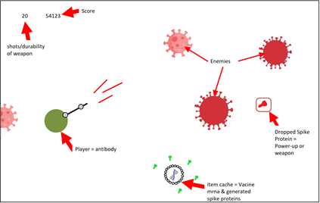

|  |  |
| --- | --- |

Current User Story UIs

* Player movement



* Enemies



* Enemy Movement



* Entity Collision



* Attack Methods



* Drop Entities



**StoryBoard:**

* Added the new game mockups to the storyboard and removed the improper user stories from it, since they were more end goals rather than implementable stories at each iteration.

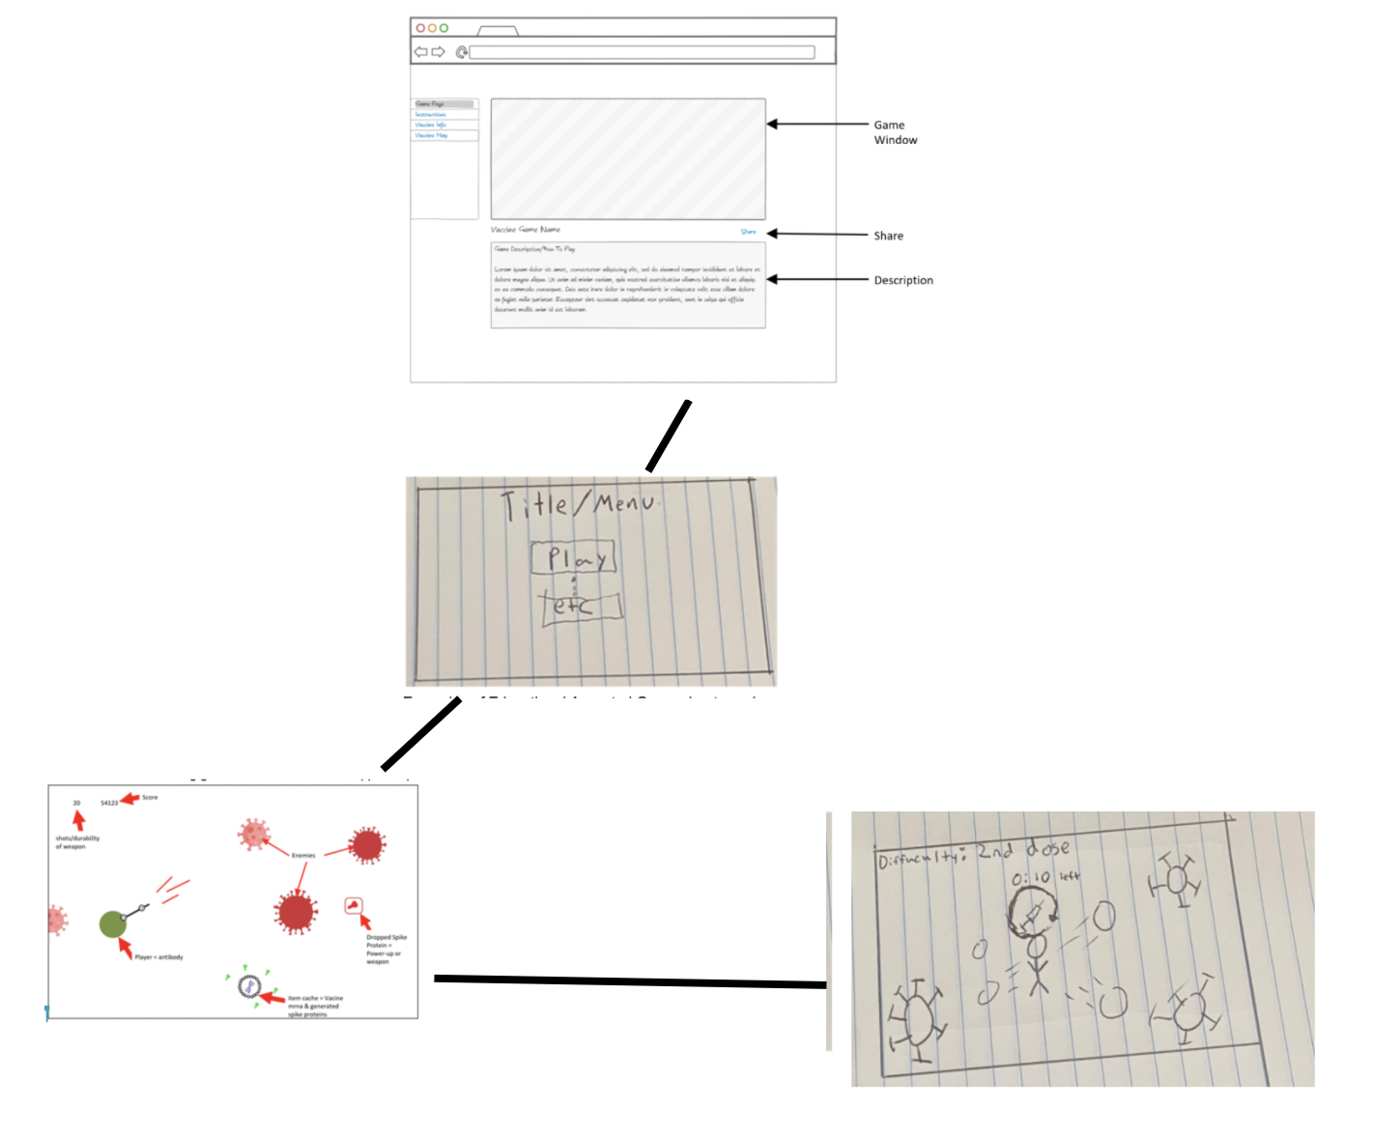

**Incomplete User Stories:**

If you were not able to implement all the stories that you initially chose for this iteration, please list which ones and why not.

* At the time of writing our previous user stories we worked under the incorrect assumption that we were to state overall goals of the different sections of our project, and in further iterations break down these overall goals into smaller goals to be completed each week. We created these goals with the mindset that since we did not have an approved game idea to work on yet, we had to decide on large software related goals rather than goals such as creating game ideas, deciding on ideas, and goals in testing and deciding on a game framework to help in development.
* In short, due to a misunderstanding about user stories, we created end goals rather than goals to be completed in a single iteration and were thus unable to complete any of our iteration 0 user stories.

**Reason For Changed Stories:**

If you have changed any of your stories, please write a short description of the changes made and the reason behind the changes.

* Once we developed an idea for our game and received feedback and approval, we had a better understanding of what user stories to break down and focus on. In iteration 0, we did not have an idea for our game so our user stories were broad. We also included work stories like writing reports, planning, demoing, and poster-making since they take a significant amount of time to complete.

**Code Tests & Evaluations:**

Evaluations of your code and tests, such as SimpleCov and CodeClimate

* Not needed for this iteration.